1. Install nginx and run nginx on port number 81.

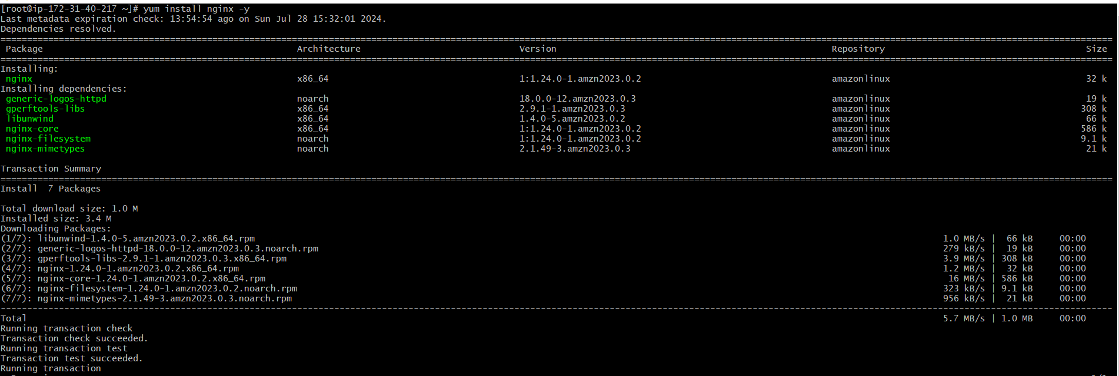



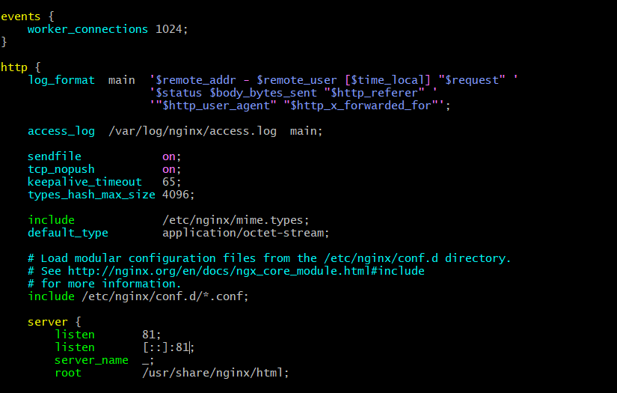

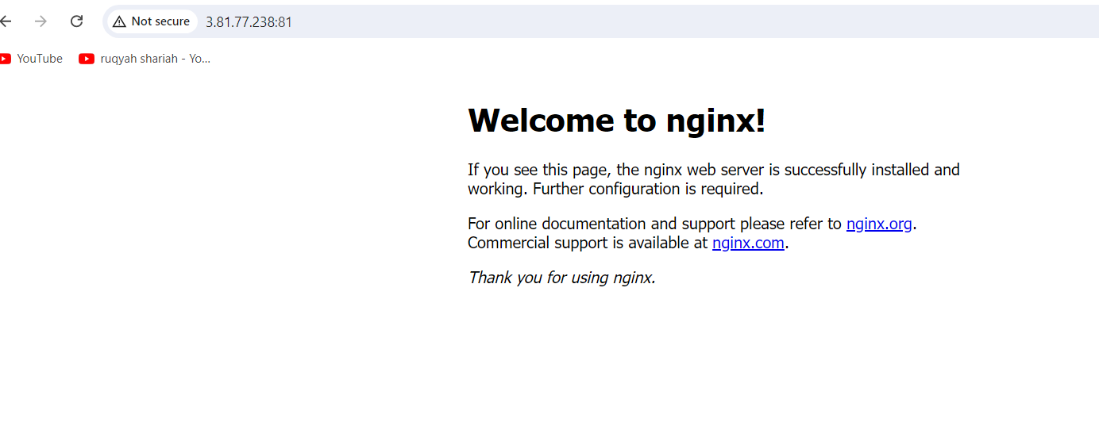

1. Deploy a sample index.html file on nginx.

1. Install Apache and run Apache on port number 82

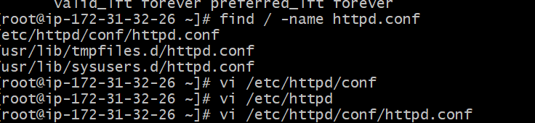

1. Deploy a sample index.html file on Apache.

1. Install Apache tomcat on port number 8082

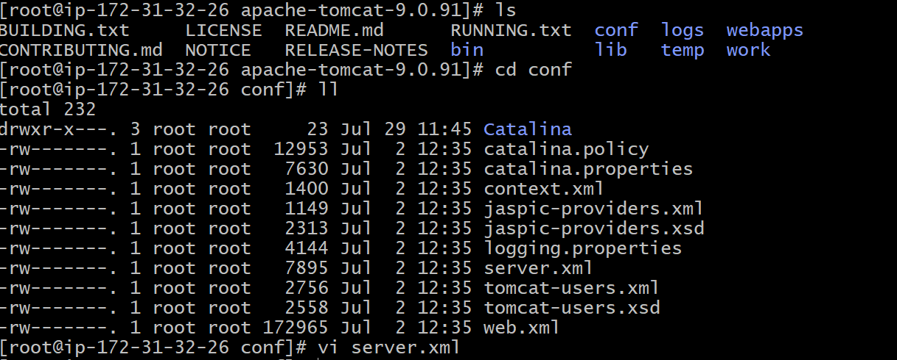

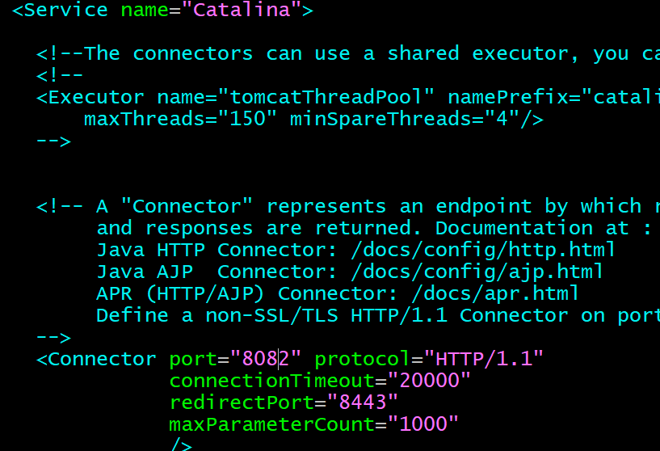

6) Deploy a sample app on webapps

7) Create a tomcat.service file for tomcat.

8) Configure HA Proxy server